2021 Subject List

- February – Mono Photography
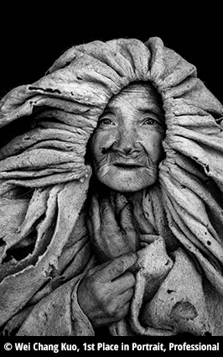
Monochrome photography is photography where each position on an image can record and show a different amount of light, but not a different hue. It includes all forms of black-and-white photography, which produce images containing shades of neutral grey ranging from black to white

Printed Material: https://petapixel.com/2014/11/24/6-black-white-photography-tips-monochrome-enthusiasts/

Videos : https://www.youtube.com/watch?v=lykFo-R-0_o

https://www.youtube.com/watch?v=reqL-VZn48Q
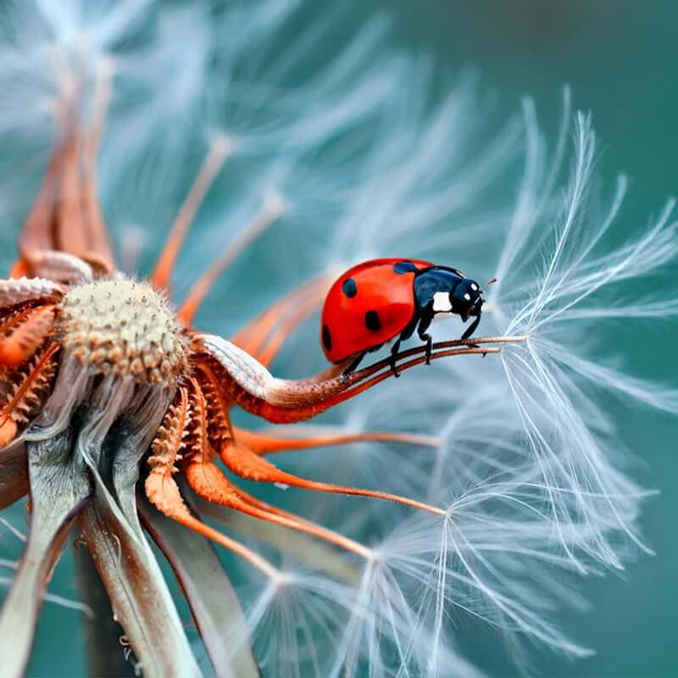

- March – Macro Photography

Macro photography is a unique form of photography that involves photographing
small objects to make them look life-sized or larger in the photo. The usual subjects
include flowers and small insects, which we don't normally get to see up close with
the naked eye

Printed Material: https://www.adorama.com/alc/top-10-macro-photography-tips
https://photographylife.com/macro-photography-tutorial

Videos : https://www.youtube.com/watch?v=8CbfL4fvH6M
https://www.youtube.com/watch?v=fT1fcwMu8jY

- April – Landscape Photography
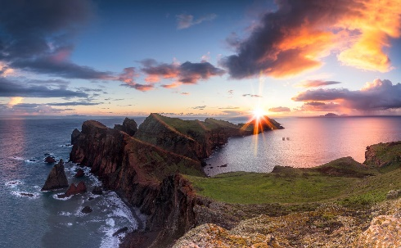
Landscape photography shows spaces within the world, sometimes vast and unending, but other times microscopic. Landscape photographs typically capture the presence of nature but can also focus on man-made features or disturbances of landscapes. Landscape photography is done for a variety of reasons

Printed Material: https://digital-photography-school.com/12-tips-to-help-you-capture-stunning-landscape-photos/
https://www.pixpa.com/blog/landscape-photography-tips

Videos : https://www.youtube.com/watch?v=X3D0mRGpzN8
https://www.youtube.com/watch?v=RB-FvfkW_3Q

- May – Light and Shadow Photography

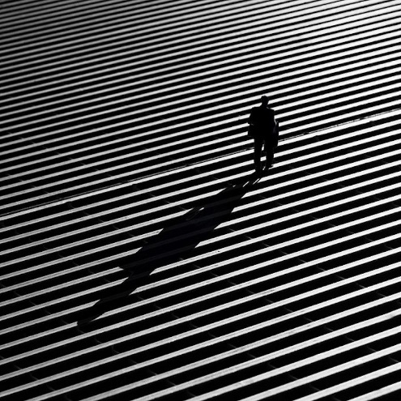
What is Light and Shadow Photography? Light and shadow photography is using strong lights and shadows to create abstract or anonymous silhouettes. Especially in monochrome with the high contrast lighting, the images create unique perspectives.

Printed Material: https://digital-photography-school.com/shadows-in-photography/
Examples and ideas : https://gr.pinterest.com/EGXX/light-and-shadow-photography/
Videos : https://www.youtube.com/watch?v=8QepsjBaRCY
https://www.youtube.com/watch?v=GLH-OP9zVYc

- June – Creativity Photography
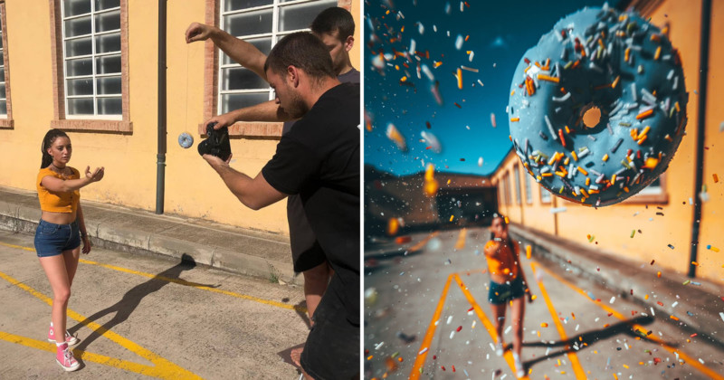
when you talk about creative photography, the field is wide open. ... They can involve a simple workflow that a photographer used to capture that unique look of a photo. Or they can be a complex post-processing technique that was used to bring out the mood and textures in an image.

Printed Material: https://visualwilderness.com/composition-creativity/what-is-creative-photography#:~:text=when%20you%20talk%20about%20creative%20photography%2C%20the%20field%20is%20wide%20open.&text=They%20can%20involve%20a%20simple,and%20textures%20in%20an%20image.

Videos : https://www.youtube.com/watch?v=2hRYxr6zWHQ
https://www.youtube.com/watch?v=LPag0iand3w&t=417s
https://www.youtube.com/watch?v=UUHnqDl89dg

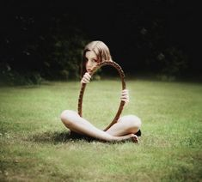
- July – Mirror Reflection or Glass Photography
Reflection photography, also referred to as mirror photography, is when you use reflective surfaces to create an artistic echo of a scene. This type of photography can add an interesting spin to locations that are hotspots for photographers such as oceans, lakes, puddles, and even rain drops. You have the option to take this subject literal and use only mirrors or glass… or it can be a mirror reflection as in reflection photography the choice is yours.

Printed Material: https://expertphotography.com/mirror-photography-ideas/
https://www.clickinmoms.com/blog/creativity-exercise-mirror-mirror-creative-reflections/
https://expertphotography.com/cloud-photography/

Videos : https://www.youtube.com/watch?v=kgGoN0VixVs
https://www.youtube.com/watch?v=GfweiLbEJ24

- August – Cloud Photography

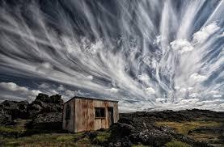
Cloudscape photography
is photography of clouds or sky. Get outside there are so many styles of clouds and ways to shoot them.
Grab a tripod and set up for some time-lapse if you like or get out on a stormy sunset or rise… see those clouds and capture them

Printed Material: https://www.photographytalk.com/how-to-photograph-clouds
https://the-pro-photographer.com/7-tips-for-taking-great-cloud-photos/
https://www.lightstalking.com/how-to-photograph-clouds/

Videos : https://www.youtube.com/watch?v=i3BaRqBpVu8
https://www.youtube.com/watch?v=b3m9k76uf5k

- September – Transport Photography (Trucks, cars, planes, trains, bikes etc)

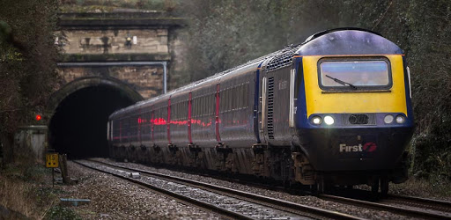
Transport Photography – Depending on your style, interests, and photographic approach, transportation can be subject for travel photography, street photography, documentary photography, commercial photography, and even fashion photography. From expensive cars and yachts to bicycles and public transportation, you have a wide range of vehicles to choose from. You may want to focus on technological achievements, like super-fast trains, or on social issues, like the importance of a cycle rickshaws in an Asian society. Or you may want to focus on cargo trucks, airplanes, or shipping companies. . You can with your shutter decide on capturing movement or freezing it.
Printed Material: https://www.ephotozine.com/article/10-top-transport-photography-tips-18820
https://annemckinnell.com/2016/03/24/how-to-photograph-modes-of-transportation/

Videos : https://www.youtube.com/watch?v=w5Epx2grWDE
https://www.youtube.com/watch?v=s2YEj7WfOWM
https://www.youtube.com/watch?v=vpZYQqp8YX4
https://www.youtube.com/watch?v=lnpc6QsoKo4

- October – Line Photography
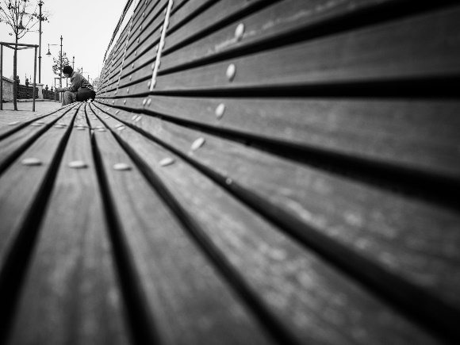
Geometric Shots – What is a line in photography definition? A line in a photo is a point that moves, leading towards something. ... This can be vertical lines, parallel lines, curved lines, diagonal lines, and even strong horizontal lines. A leading line helps the viewer's eye move from one part of the image to another.​

Printed Material: https://digital-photography-school.com/how-to-use-leading-lines-for-better-compositions/
https://www.picturecorrect.com/tips/an-intro-to-line-shape-and-form-in-photography/

Videos : https://www.youtube.com/watch?v=j6AP49hI3e0
https://www.youtube.com/watch?v=Oou0eAZ9OsU
https://www.youtube.com/watch?v=3zx-DOL4a8c

- November - Night Photography

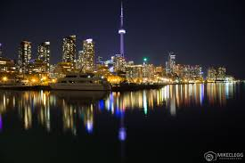
When speaking about night photography and what there is to it, the first thought is long exposure, car light trails, city lights, trains at night, boats at night like ferries etc. While this is correct, there is a lot more to night photography and since we have more time for our exposure, this might mean endless fun. Light painting, steel wool twirling, fire twirling and many more too.

Printed Material: https://digital-photography-school.com/introduction-to-night-photography/
https://www.canva.com/learn/9-night-photography-techniques-capture-detailed-scenes-limited-lighting/
https://digital-photography-school.com/tips-for-getting-proper-exposure-for-night-photography/

Videos : https://www.youtube.com/watch?v=g6DIaFnnCiI
https://www.youtube.com/watch?v=NPJVj4qI9AI
https://www.youtube.com/watch?v=CFlgMdiZHhc

- December – your pick of any 3 entries you did during the year for entry into Image of the Year – only requirement is it must be as you entered it with no alterations.

